

**Group**

**Volunteering Wellington**



**Volunteers are the backbone of what we do at RMHC New Zealand. We simply couldn’t support families the way we do without the thousands of volunteers who come through our doors, roll up their sleeves and make RMHC New Zealand a ‘home-away-from-home’ for the families staying with us.**

**We hope you choose to book a session and we look forward to welcoming you to the RMHC New Zealand whānau.**

**New Zealand**

|  |  |  |  |  |  |
| --- | --- | --- | --- | --- | --- |
|  | **Monday** | **Tuesday** | **Wednesday** | **Thursday** | **Friday** |
| **FAMILY DINNER PROGRAMME** |  | **FAMILY DINNER NIGHT**  3:00PM – 8:00PM    $500 6-8 |  | **FAMILY DINNER NIGHT**  3:00PM – 8:00PM  $500 6-8 |  |
|  |  |  |  |  |  |
| **GENERAL HELPING SESSIONS** |  |  | **WORKING**  **BEES**  Wednesdays as needed  **BAKING GROUPS**  Fortnightly Wednesdays  10:30AM – 2:30PM    Free 4-8 |  |  |



Number of volunteers needed in your group

Costs associated (indicated cost is inclusive of GST)

**GROUP VOLUNTEERING OPTIONS**

**Grafton Mews House**

**FAMILY DINNER NIGHT**

**3.00pm - 8.00pm**

**$1,000 6- 8**

**Grafton Mews House**

**FAMILY DINNER NIGHT**

**3.00pm - 8.00pm**

**$1,000 6- 8**

**WORKING BEE 9:00AM – 1:00PM**

**FREE 4 - 6**

**FAMILY DINNER NIGHTS**

FAMILY DINNER NIGHT WELLINGTON HOUSE

A rewarding team volunteering experience - you’ll be cooking

dinner for up to 40 people, so expect a fast-paced afternoon. Your team will cook, serve dinner, and clean up yourselves. The menu and ingredients are organised for you, so catering experience is not needed - just a keen, can-do attitude.

**Logistics:** Tuesdays and Thursdays, 3.00pm - 8.00pm at Wellington House

**Group size:** 6 - 8 people

**Menu:** RMHC organises menu and ingredients

**Cost: $500** (incl. GST)* to cover food costs

**Please note:** Any Family Dinner booking cancelled within 48 hours of your confirmed date will be forfeited and non-refundable. Ingredients will already have been purchased, and meals will need to be provided to families.

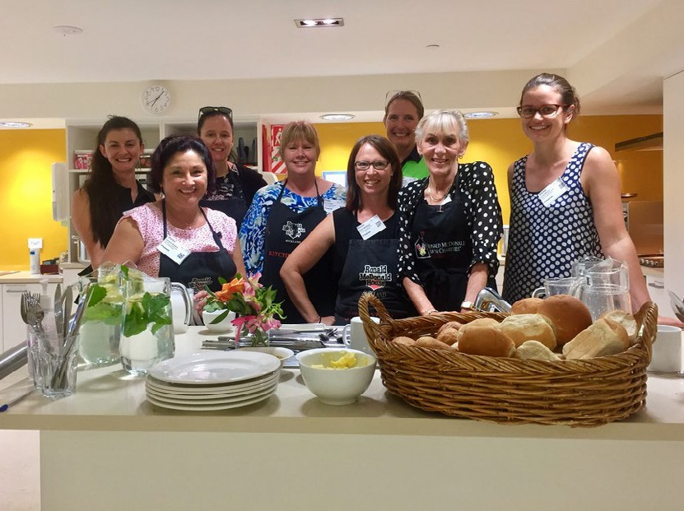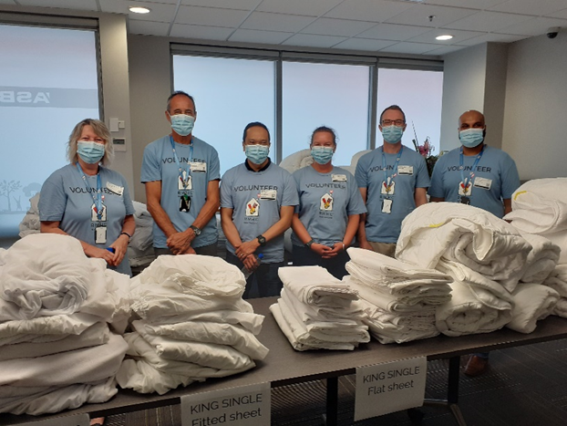

WORKING BEES

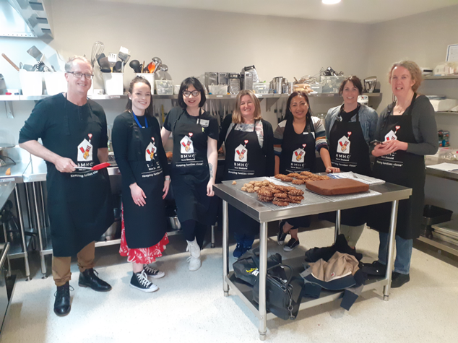

BAKING GROUPS

**Working Bees:**

If you’re up for anything that will be helpful to the families, this is the option for you. Your activity will be determined the week you volunteer, based on needs in the House. From small maintenance jobs to moving furniture, making beds, to sorting donated goods and helping with fundraising event preparations.

**Logistics:** Wednesdays as needed, 10.30am – 2.30pm

**Group size:** 4 - 6 people

**Cost: Free**

**Baking Groups:**

Get a group together to come along and bake treats for our families. Bring along some recipes and the ingredients (we will provide the basics) and a spirit for sharing the love and cook up at storm in our volunteer kitchen.

**Logistics:** Fortnightly Wednesdays, 10.30am – 2.30pm

**Group size:** 4 - 8 people

**Cost: Free**

**GENERAL HELPING SESSIONS**

**How does the payment process work?**

Two months before your volunteering session we will send you an invoice for the ingredients for your session. This is due two weeks before your session. You can pay by direct debit or credit card over the phone.

Refunds will only be provided if more than two weeks’ notice is given, and a suitable postponement date cannot be found.

Note, these are not tax-deductible donations as they are solely paying for food ingredients.

**How did you decide the costs?**

Analysis of our financial records shows that the average cost to provide a nutritious evening meal to an RMHC NZ family is $10.00 per person. We anticipate that each Family Dinner Night will be catering for 40 people. The cost of $500 incl gst is for the purpose of covering our average food costs.

**FREQUENTLY ASKED QUESTIONS**

**How do I book?**

Our group volunteering sessions are very popular, so we recommend booking 2+ months in advance to avoid disappointment. The more notice we have the more likely we’ll be able to find a volunteer opportunity to suit your group.

**If it’s your first time volunteering:**

Please sign up online here:

**https://rmhc.org.nz/group-volunteering-opportunities-wellington/**

Signing up online saves you and our team a lot of time. You will be able to see which sessions are available or taken and easily apply for the session(s) you would like, without lots of emailing.

**If your team has volunteered before:**

Sign-in to your volunteer page here: https://app.betterimpact.com/Login

If you can’t remember your username or password, click the ‘Forgot your username or password?’ link and enter your email address so you can reset these. If you continue having problems, please email [volunteering@rmhc.org.nz](mailto:volunteering@rmhc.org.nz)

**How many sessions can I book?**

We want to give as many people the opportunity to volunteer as possible so your group can apply for up to two group volunteering sessions per year.

Anything more than this will be at RMHC New Zealand’s discretion.

You can give us more details about your group size, availability and

interests and we will see if we can find a bespoke volunteering opportunity for you. Our National Group Volunteering Coordinator will then be in touch to discuss date and time options to find a solution that could work for your group.

If we can’t accommodate your group for a volunteering session there are many other ways to support RMHC New Zealand, whether this is holding your own fundraiser, attending one of our fundraising events, donating or much more.

For more ways to support us visit:

**https://rmhc.org.nz/support/**

**Please note:** Any Family Dinner booking cancelled within 48hours of your confirmed date will be forfeited and non-refundable. Ingredients will already have been purchased, and meals will need to be provided to families.

**FREQUENTLY ASKED QUESTIONS**

**What if none of these volunteering options suit our group?**

If you have your heart set on volunteering, we still recommend signing up online here:

**https://rmhc.org.nz/group-volunteering-opportunities- wellington/**